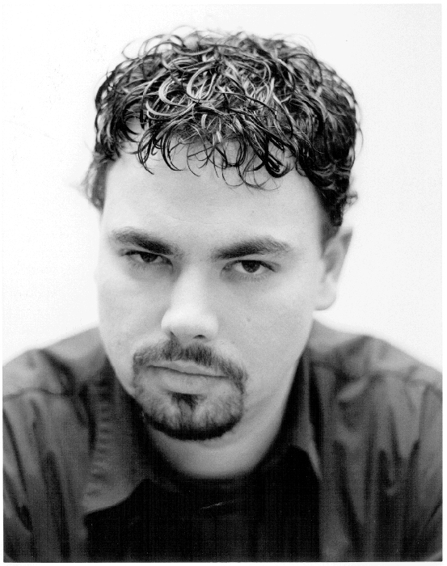
Jeff White
Member, ACPA · Non-Union Status

Height: 6’0”
Weight: 210-230 lbs.
Hair: Black
Eyes: Brown
Age Range: 25-35
Voice: Baritone
Phone: (770) 310-6312
Email: jeffwhiteactor@lycos.com

Theater

Production Role Theater Company
Inherit the Wind (Staged Reading) Corkin/Radio Man Atlanta Classical Theatre, Atlanta, GA
Chasing Home (Staged Reading) Grandpa/Joe Wiseman Anthony Farrell, playwright
A Christmas Carol (Staged Reading) Reader 2 Fayette County (GA) Public Library
A Midsummer Night’s Dream Demetrius/Snout Atlanta Classical Theatre, Atlanta, GA
Big Show, Small Box Ensemble Galaxy Productions, Decatur, GA
Bells Are Ringing Sandor Stage Door Players, Dunwoody, GA
Clue Mr. Boddy/FBI Agent Kudzu Playhouse, Roswell, GA
West Side Story Moose Theater Arts Guild, Clarkston, GA
The Star-Spangled Girl Andy Hobart Oconee Co. Arts Foundation,
Watkinsville, GA
Big River Pap/Silas Phelps Rome Little Theater, Rome, GA

Television

Production Role Producer
Boat Shopper Online (commercial) VO Rich Vogan, ATP, Atlanta, GA
PeachStar Classroom Instructor Georgia Public Broadcasting,
(2003 Telly Award Finalist – Video Production) Atlanta, GA
August Children’s Pledge Drive Talent GPTV, Atlanta, GA
Cobb Co. ADAD Host TV23, Marietta, GA

Film

Production Role Producer
Quest Robber Will Burns
Obedience Matthew Atlanta Urban Mediamakers, Inc.
Gadget Addict Friend in Elevator Metro Public Arts Coalition,
Atlanta, GA

Additional Experience
ACT Actor’s Ensemble (premier season) Ensemble Member ACT, Atlanta, GA
2002 Season Moldavian Baron/Combatant Georgia Renaissance Festival,
Fairburn, GA
Bard-a-Thon Fundraiser Reader Soul-stice Repertory Ensemble,
Atlanta, GA

Additional Training
Basic Stage Combat – Nils Onsager, 2003
Audition workshop – Alliance Theater, February 2003
Video Production Class – Georgia Public Broadcasting, July 2002
Stage Combat Boot Camp – Georgia Renaissance Festival, 2002

Special Skills
Employed at Georgia Public Broadcasting
Stage combat and competitive fencing experience
Capable with foreign and regional dialects
Can read music, dance, play guitar

